Power BI End Module Project Report
AI-Powered Fleet Performance & Delivery Efficiency Dashboard

Name: Sowbarnika Sri
Batch: TN_DA_FNB07
Contact No.: 91 8489439449
Email ID: asurevthi@gmail.com
Submission Date: 10-Dec-25
Power Bi File: Power Bi Module End Assignment

1. Project Purpose
The purpose of this project is to analyse delivery operations using Power BI to understand fuel usage, delivery efficiency, cost per km, and vehicle performance. The insights help management improve fleet utilization, reduce maintenance cost, and increase on-time delivery rate.
2. Project Objective
- Clean and combine trip
-level data and vehicle details
- Fix missing values
- Build relationships using Vehicle_ID
- Create DAX measures for performance metrics
- Build dashboards for delivery performance
- Use AI visuals to explore influencers and patterns
- Generate insights for fleet optimization
3. Data Cleaning Steps
Trip_Data:
- Distance: Checked numeric type, removed nulls
- Fuel_Consumed: Missing values replaced using mean imputation
- Maintenance_Cost: Verified numeric
- Status: Standardized (“On-Time”, “Late”)
- Delivery_Time: Outliers checked
- Delivery_Date: Converted to date format
- Vehicle_ID: Used for relationship creation
Vehicle_Master:
- Vehicle_ID: Duplicates removed
- Vehicle_Type: Normalized text
- Capacity: Verified numeric
- Registration No: Checked for missing

- Data Cleaning & Modelling:

Fix missing fuel consumption values (use mean imputation).

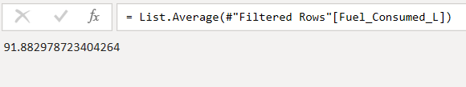

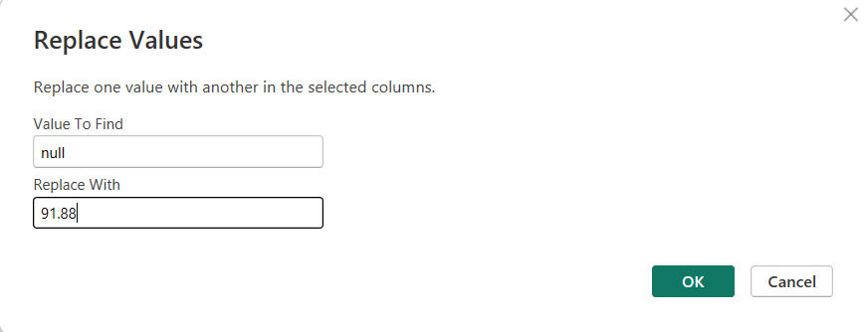
Relationship using Vehicle_ID between Trip_Data and the Vehicle
Master table.

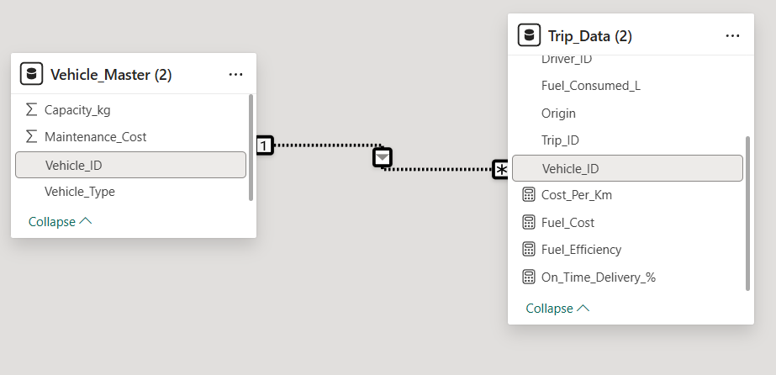

- DAX Measures:

1.Fuel Efficiency = Distance / Fuel Consumed

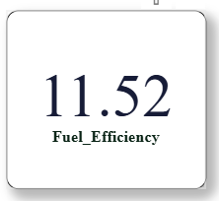
2.On-Time Delivery % = On-Time Trips / Total Trips:

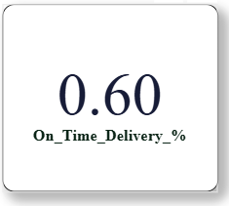

3.Cost per km = (fuel cost + Maintenance Cost) / Distance

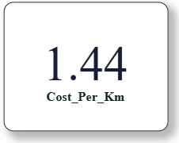
- Visualization:

Bar chart: On-Time Delivery % by Destination.

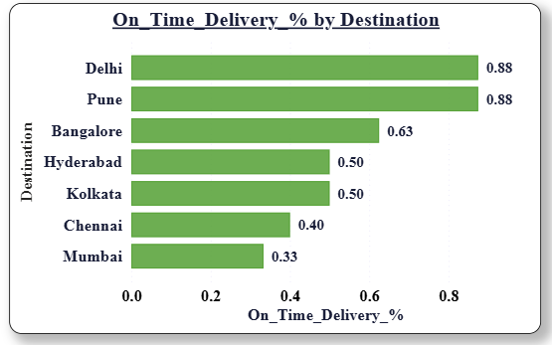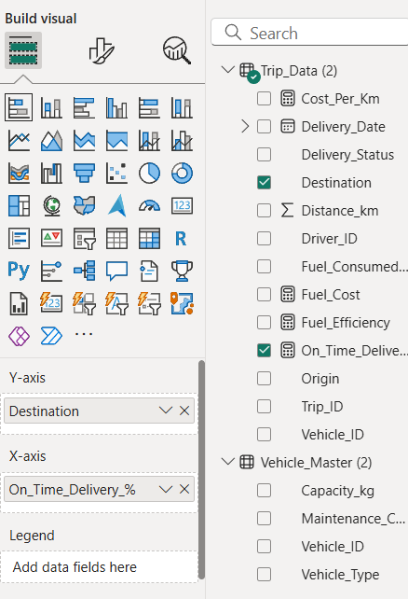

Line chart: Fuel efficiency trend by delivery date.

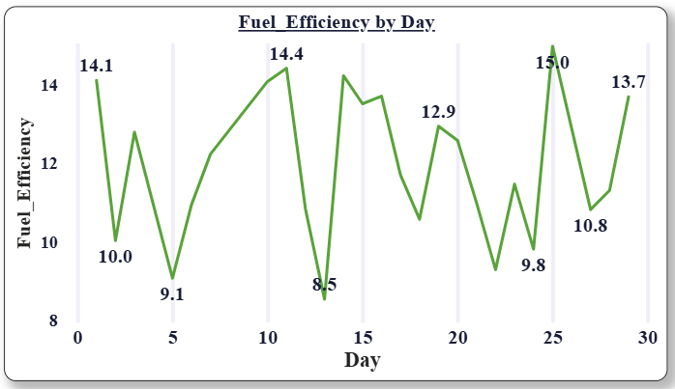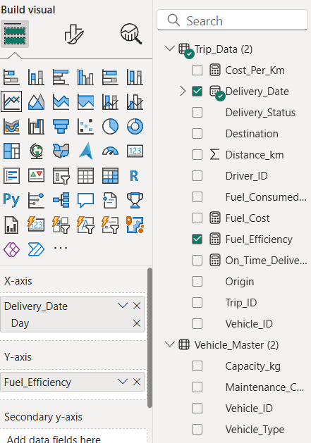

Cards visualization:

■ Avg. Delivery Time

■ Average cost per km
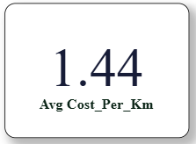

Pie chart: vehicle type vs Average maintenance cost

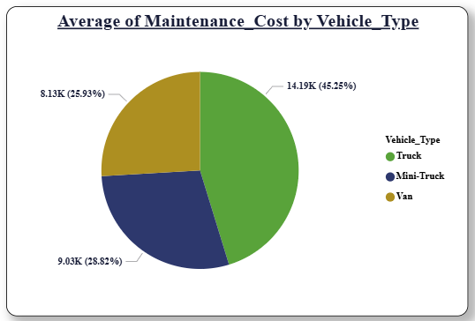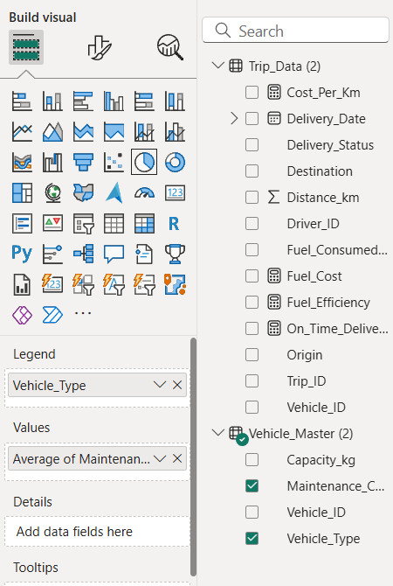

- AI-Powered Visuals
❖ Q&A Visual: Average Cost per km by vehicle type

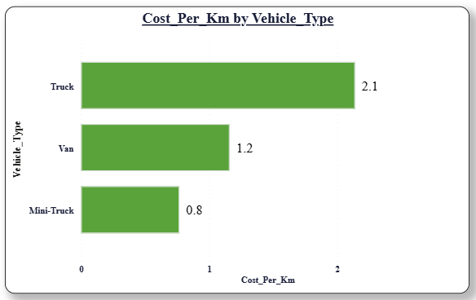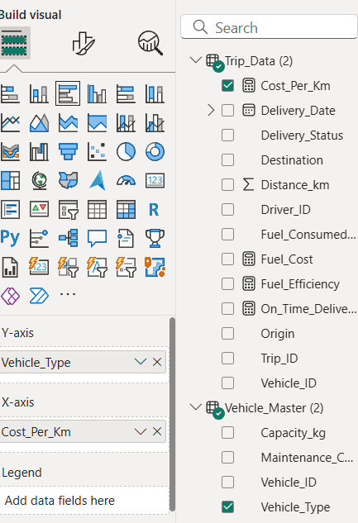

Key Influencers Visual:
Delivery Status by -distance in km, vehicle type, Driver_ID
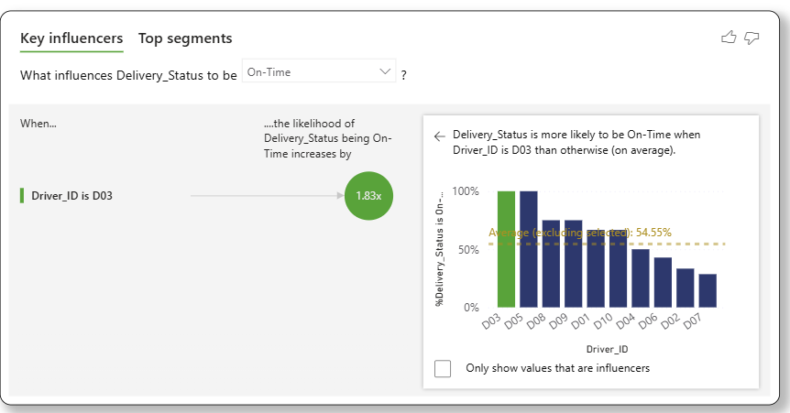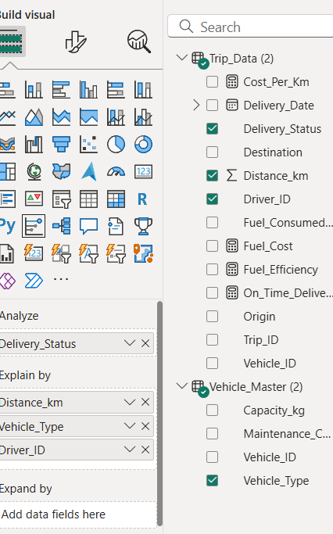

Decomposition Tree (AI Visual):

Cost per km by Vehicle Type, Maintenance_cost,
and Distance_km.

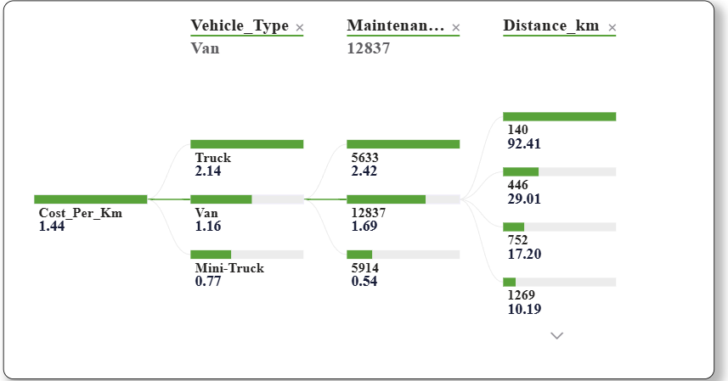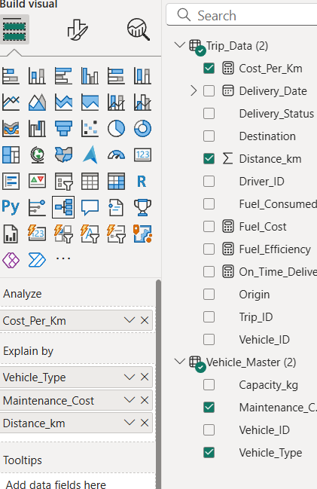
DASHBOARD
